**Alphabet Soup Deep Learning Analysis**

Overview:

The nonprofit foundation Alphabet Soup wants a tool that can help it select the applicants for funding with the best chance of success in their ventures. With your knowledge of machine learning and neural networks, you’ll use the features in the provided dataset to create a binary classifier that can predict whether applicants will be successful if funded by Alphabet Soup.

**Results:**

Data Preprocessing-

* What variable(s) are the target(s) for your model?
  + The target variable is the “IS_SUCCESSFUL” column
* What variable(s) are the features for your model?
  + The features are the other columns that are left.
* What variable(s) should be removed from the input data because they are neither targets nor features?
  + I removed the “NAME” and “EIN” column since they were not needed for our model.

Compiling, Training, and Evaluating the Model-

* How many neurons, layers, and activation functions did you select for your neural network model, and why?
  + There were 13 total hidden layers. The activations functions used were the relu and sigmoid functions
* Were you able to achieve the target model performance?
  + Yes. The model obtained 96% accuracy.

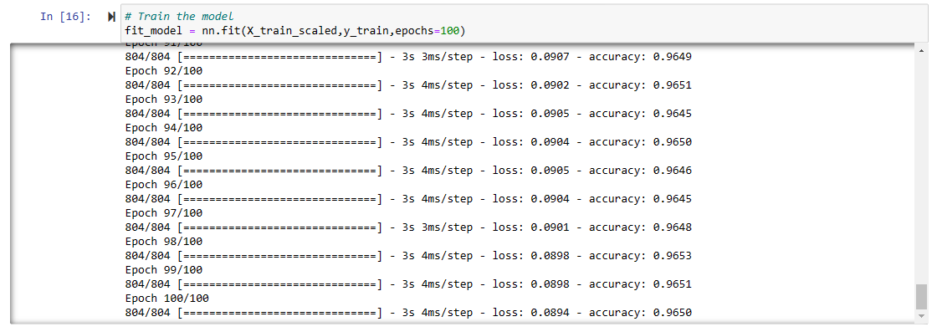

* What steps did you take in your attempts to increase model performance?
  + No extra steps were needed as the model reached target performance.